**Project Design Phase-I**

**Solution Architecture**

|  |  |
| --- | --- |
| Date | 9th October 2023 |
| Team ID | PNT2023TMID592830 |
| Project Name | Project – Travel Insurance Prediction |
| Maximum Marks | 4 Marks |

**Solution Architecture:**

Tech Solution:-  
We use the jupyter to create the prediction part of this topic and we import the following  
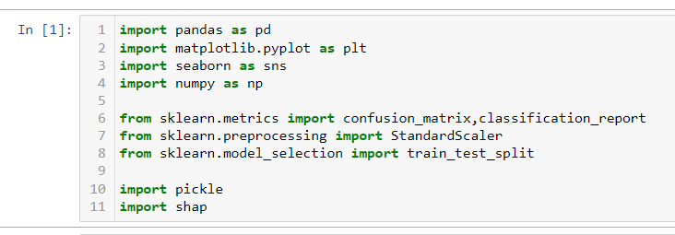  
 we use the above to get the required output.  
After this we use spyder to create the webapp where we have 2 phases the backend and the frontend. Here for Backend we use python while for frontend we use html.  
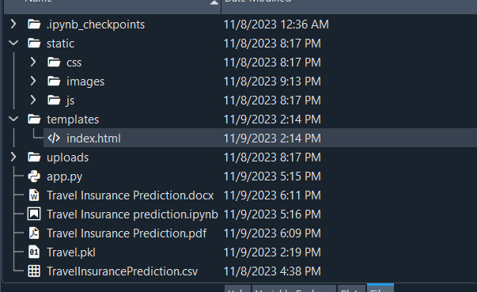

Backend  
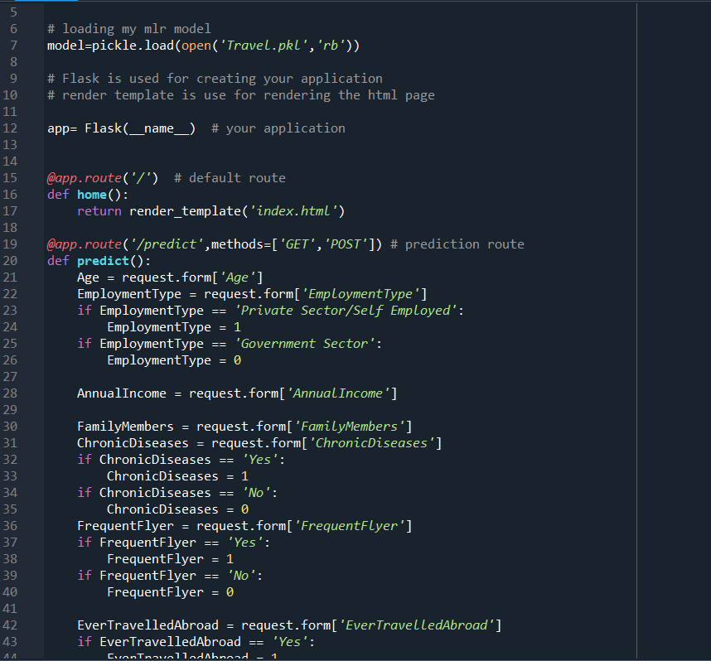

Frontend  
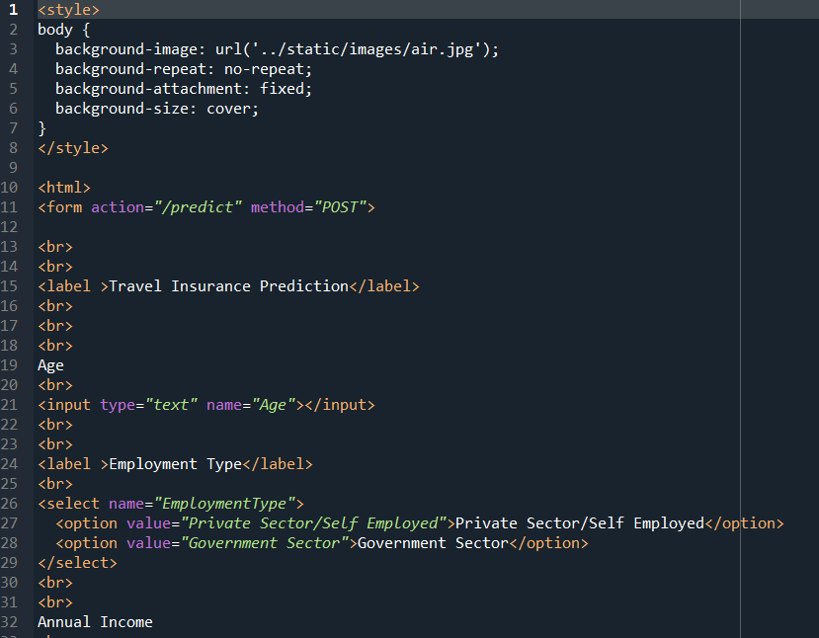

The accuracy of the prediction is pretty good since we have used around 5 different methods they are:-  
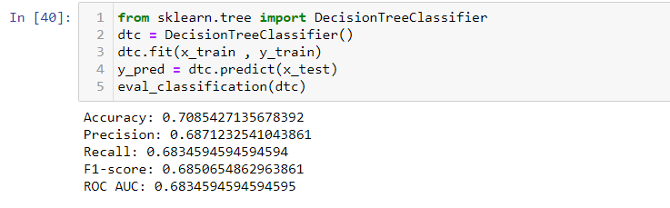  
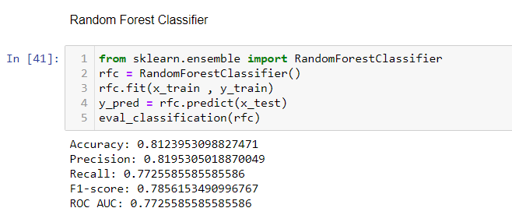  
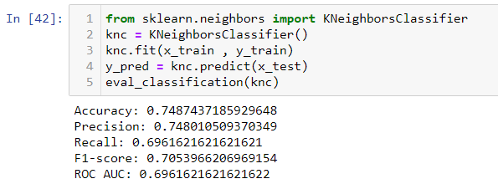  
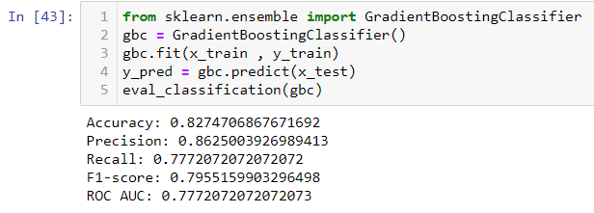  
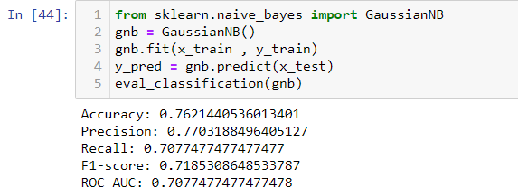

By using the above methods we have managed to get a good prediction of whether this would be useful to the customer or not.

**Solution Architecture Diagram:**

